Tutorial Chapter 3

**Website Case Study**

**JavaJam Coffee House**

**Task 1: The External Style Sheet. Use an external style sheet named javajam.css. Code the CSS to configure the following:**

1. Global styles for the document (use the body element selector) with background color #ffffcc; text color #330000; and Verdana, Arial, or nay sans-serif font.
2. Styles for the header element selector that configure background color #ccaa66, text color #000000, and centered text.
3. Styles for the h1 element selector that configure 200% line height.
4. Styles for the nav element selector that configure centered text.
5. Style for the footer element selector that configure background color #ccaa66, text color#000000, small font size (.60em), italics, and centered text.

**Save the file as javajam.css. Check your syntax with the CSS validator. Correct and retest if necessary.**

**Task 2: The Home Page. Open the index.html and apply styles from the javajam.css.**

1. **Configure the page footer area. Remove the <small> and <i> elements – they are no longer needed since CSS is now used to configure the text.**

**Task 3: The Menu Page. Open the menu.html file. Modify this file in a similar manner as you modified the home page.**

**Task 4: Center page layout with CSS.**

1. **Open javajam.css. Add style rule for an id named wrapper with width set 80%, margin-right set to auto, and margin-left set to auto.**

**Experiment with modifying the javajam.css file. Change the page background color, the font family, and so on. Test your pages in a browser. Isn’t it amazing how a change in a single file can affect multiple files when external style sheets are used?**

**Sample Output:**

**index.html**

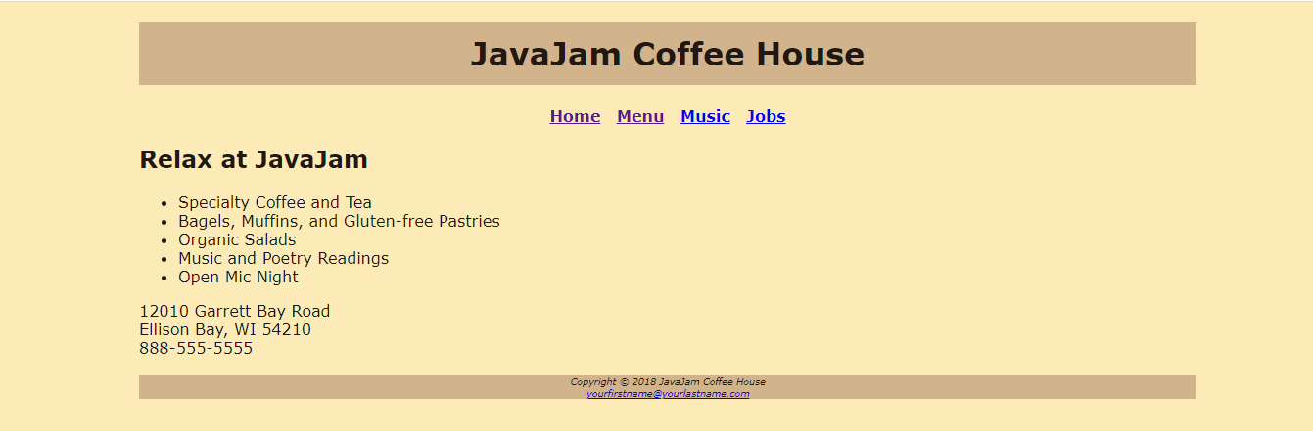

**menu.html**

